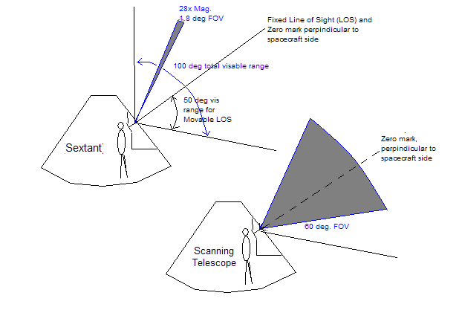
Standard Viewing Angles

Shaft Controls the rotation around zero mark.
Trunion controls the azumith.

Shaft is limited to +/- 270 degrees from pre-defined zero point.
Trunion can rotate the FOV 90 degrees although only 50 degrees from zero point are visible.

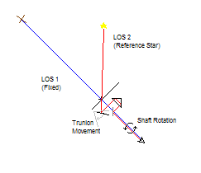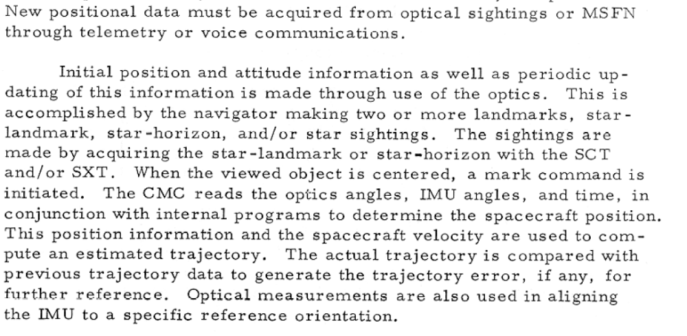

Method of Alignment:
- Zero Switch to Zero to reset Trunion and Shaft
- Using Rotational Controller in LEB loosely align the spacecraft with a fixed landmark using the Scanning Telescope.
- Using Minimum Impulse Controller (Lwr. Right of panel) align craft with fixed landmark while looking through sextant.
- VERIFY MODE to MAN and TELTRUN to Slave to SXT.
- Using Sextant Trunion Controller (Lwr. Left of panel), loosely align trunion with reference star of choice.
- Viewing through Sextant, align reference star with fixed landmark.
- Press MARK to send values to CMC.
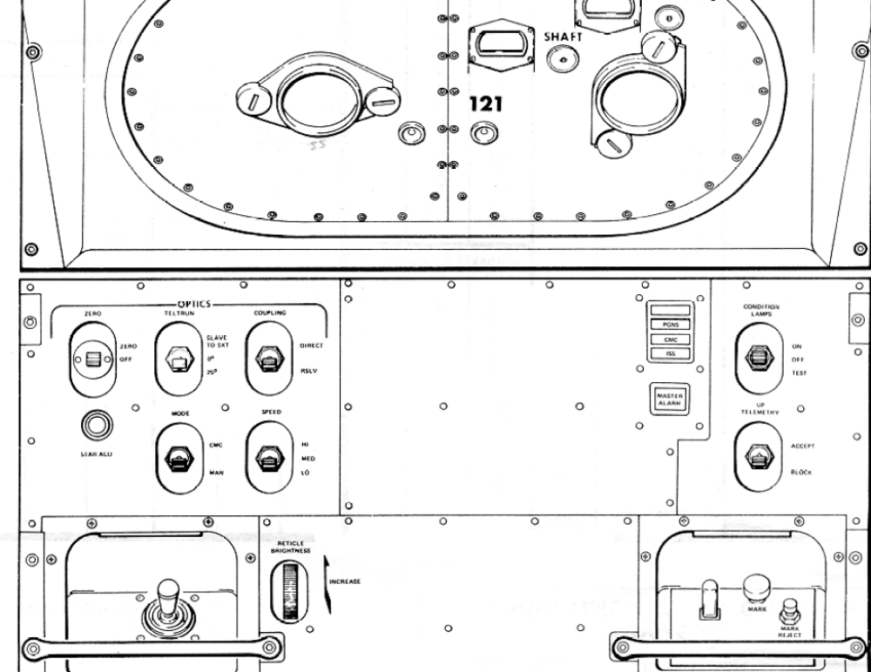

Switch Functions:

Zero: (momentary) Flipping the switch to zero will send a signal to the CMC that aligns the Sextant and Telescope Trunion along the Sextant’s Fixed LOS, perpendicular to crafts side. Aligns Shaft to the zero point as well.

TELTRUN: (three position) Describes Telescope Trunion relationship to Sextant Trunion. SLAVE TO SXT means the Telescope Trunion moves with Sextant Trunion. 0 DEG aligns Telescope Trunion with Zero Point. 25 DEG places Trunion at fixed 25 degrees from Zero Point. The 60 degree FOV of the Telescope now covers the entire sky viewable in the sextant (capable of only 50 degrees off the zero point).

COUPLING: (toggle) DIRECT translates Trunion Hand Controller directly (Up moves trunion toward, down away, from zero point and left rotates Shaft counter-clockwise, right rotates shaft clockwise) RSLV resolves Hand Controller movements to image movements (up translates into shifting the image down, etc.)

MODE: (toggle) CMC means the Trunion and Shaft are controlled by the CMC. MAN uses the Hand Controller to align it.

SPEED: (three position) HI the Hand Controller movements translate into 20 degrees per second for shaft and 10 degrees per second for trunion. MED is approx half that (10 and 5) and LOW is approx 4 and 2 degrees per second respectively

MARK: (Pushbutton) Sends Sextant data back to CMC.

MARK REJECT: Removes previous Sextant data from CMC.

CMC interaction:

When CMC is controlling the Trunion and Shaft, it sends out pulses from the CDU, these translate into one pulse per 5 arc seconds rotation for the Trunion and one pulse per 40 arc seconds rotation for the Shaft.

I/O Channels

Out 12: (d-c signals sent to PGNCS)
B1- Zero Optics to ECDU
B2- Optics Error Controller to ECDU
B10- CMC Enable/Zero Optics
B11- Disengage Optics DAC

Out 14: (CMC Optics Control) 1 is true
B11- SOPCDU (operate Shaft)
B12- TOPCDU (operate Trunion)

In 16: (Mark) 1 is true
B6- Mark
B7- Mark Reject

In 32: (Min Impulse Controller) 0 is true (inverted)
B1- Pitch Up
B2- Pitch Down
B3- Yaw Right
B4- Yaw Left
B5- Roll Right
B6- Roll Left

In 33: (d-c signals from optics switch/relay closures) 0 is true (inverted)
B4- Zero Switch
B5- Optics Mode

Input Counter: (keeps track of trunion/shaft values)
0034 (Trunion)
0035 (Shaft)
NOTE: 15 seconds after Zero Switch is flipped, the CMC will reset these values and begin taking new data from CMC.

MORE INFO:

G&N section of AOH

G&N section of CSM Systems handbook

SPACE NAVIGATION AND GUIDENCE VOLUME 2
http://ntrs.nasa.gov/archive/nasa/casi.ntrs.nasa.gov/19660019469_1966019469.pdf

